SERVICES DURING THE STAY

Beach towels will be in the room by arrival and can be changed at the towel desk in Bougainvillea.
Lake House guests may swim in their own pool; have their own chaise lounge and sunbath on their own terrace.
Turn down service is free of charge.
WİFİ is free of charge.

** In addition to this concept, our guests who staying in lake houses can also benefit from the
Ultra All Inclusive concept.

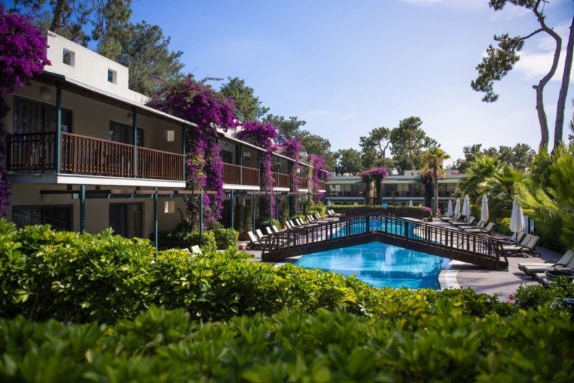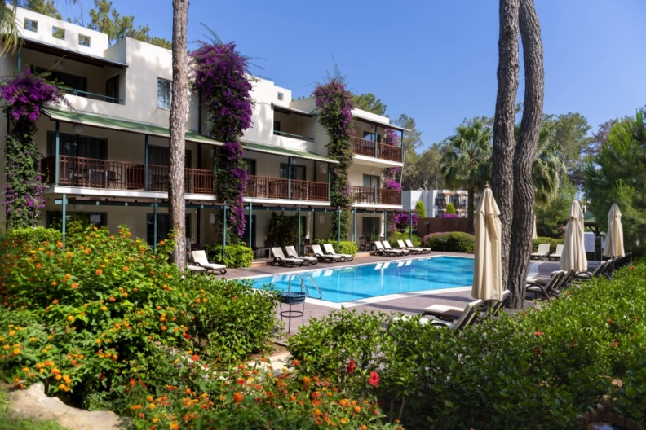
ACCOMODATION

Details about our lake houses in the garden are given in the table below.
Room Type | Location | m² | Room description | Capacity
3 Rooms Lake House with terrace | in the garden | 75 | 2 sleeping rooms (one room with a French bed, a room with 2 single beds) and a living room with a sofa. Connecting door is available. It has 2 bathrooms (wc/shower). Laminated floor, hair dryer, bathrobe/slippers, individual air conditioning, direct dial telephone, mini bar (water, soft drinks and beer), kettle and tea / coffee, safe box (free of charge), satellite TV and music over TV channels available. These rooms have a terrace and open directly to the pool. An extra baby bed can be added to the maximum stay. | Max. 5  Adults.
3 Rooms Lake House with balcony | in the garden | 72 | 2 sleeping rooms (one room with a French bed, a room with 2 single beds) and a living room with a sofa. Connecting door is available. It has 2 bathrooms (wc/shower). Laminated floor, hair dryer, bathrobe/slippers, individual air conditioning, direct dial telephone, mini bar (water, soft drinks and beer), kettle and tea / coffee, safe box (free of charge), satellite TV and music over TV channels available. These rooms have a balcony. An extra baby bed can be added to the maximum stay. | Max. 5  Adults.
2 Rooms Lake House with terrace | in the garden | 73 | 2 sleeping rooms (one of them with a French bed, a room with 2 single beds). Connecting door is available. It has 2 bathrooms (wc/shower). Laminated floor, hair dryer, bathrobe/slippers, individual air conditioning, direct dial telephone, mini bar (water, soft drinks and beer), kettle with tea /coffee, safe box (free of charge), satellite TV and music over TV channels are available. These rooms have a terrace and open directly to the pool. An extra baby bed can be added to the maximum stay. | Max. 4 adults.
2 Rooms Lake House with balcony | in the garden | 70 | 2 sleeping rooms (one of them with a French bed, a room with 2 single beds). Connecting door is available. It has 2 bathrooms (wc/shower). Laminated floor, hair dryer, bathrobe/slippers, individual air conditioning, direct dial telephone, mini bar (water, soft drinks and beer), kettle with tea /coffee, safe box (free of charge), satellite TV and music over TV channels are available. These rooms have a balcony. An extra baby bed can be added to the maximum stay. | Max. 4 adults.
1 Room Lake House with terrace | in the garden | 36 | Room with a French bed or twin bed, bathroom (wc/shower), laminated floor, hair dryer, bathrobe/slippers, individual air conditioning, direct dial telephone, mini bar (water, soft drinks and beer), kettle with tea /coffee, safe box (free of charge), satellite TV and music over TV channels are available. These rooms have a terrace and open directly to the pool. An extra baby bed can be added to the maximum stay. | Max. 2 adults.
1 Room Lake House with balcony | in the garden | 34 | Room with a French bed or twin bed, bathroom (wc/shower), laminated floor, hair dryer, bathrobe/slippers, individual air conditioning, direct dial telephone, mini bar (water, soft drinks and beer), kettle with tea /coffee, safe box (free of charge),satellite TV and music over TV channels are available. These rooms have balcony. An extra baby bed can be added to the maximum stay. | Max. 2 adults.
PETS ARE NOT ALLOWED

** In accordance with the law no 4207, the use of tobacco, tobacco products, shisha and e-cigarettes is prohibited in closed areas. Those who do not comply with this rule will be penalized.

FOOD & BEVERAGE SERVICES
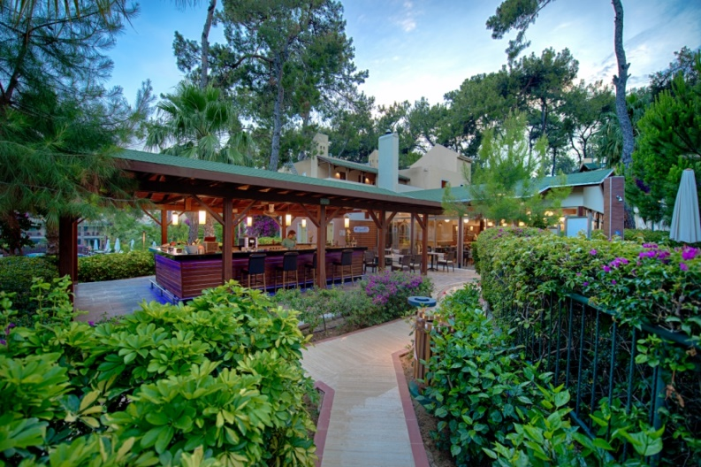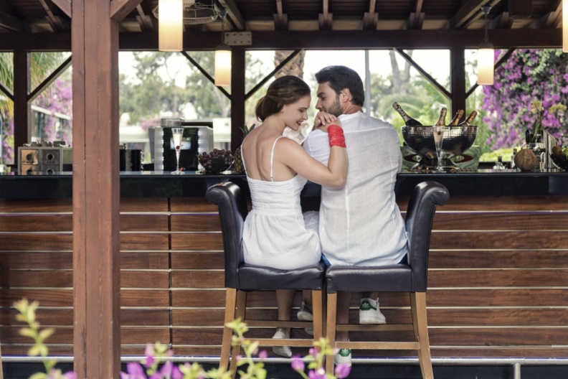

At check-in along with a welcome card, dried fruit, nuts and wine are served together.
The breakfast at the Bougainvillea Restaurant is in buffet style.
The lunch at the Bougainvillea Restaurant is a la carte style.
The dinner (World Cuisine) at the Bougainvillea Restaurant is a la carte style. Reservation for dinner is necessary according to the availability.
Fresh orange juice for breakfast is free of charge.
Waiter service (beverages) to the chaise lounge is available in the daytime.
Fruit, ice and cold towels are served to the guests who are resting at the sun loungers.
Mini Bar is filled with soft drinks, soda, water and beer (free of charge). Mini bar will be refilled every day once a day depending on consumption.
Room service is available 24 hours at extra cost.

** It is forbidden to remove food outside the restaurant due to hygiene conditions. (Those who insist to remove the food are kindly warned.)
**As required by law in Turkey, it is forbidden to serve and sell every kind of alcoholic drinks to guests who are under 18 years. Parents are responsible for their children.
**In all bars bottle service is not available
**In Bougainvillea Restaurant at dinner time there is a Dress Code for all guests. (Those who do not fit the dress code are kindly warned.)
** Our guests are assisted if they report food allergen status.

A LA CARTE RESTAURANTS

Dragon Asian Restaurant : 19.00 - 21.30 for a charge
Italien Restaurant : 19.00 - 21.30 for a charge
Steak House Restaurant : 19.30 - 21.30 for a charge (open between 20 May. – 20 Okt.)
Bougainvillea Restaurant (world kitchen) : 19.00 - 21.30 for a charge
(Bougainvillea Rest. is free of charge for Lake House Guests).

A la carte reservation;
** Reservations for à la carte Restaurants must be made at least the day before for the following day between 11:00–16:00 at the Guest Relation Desk.Based on availability.
** The à la carte Restaurants need minimum 10 guests for opening.
** High Class Beverages and Quality Wines are available from menu card at our à la carte Restaurants with extra charge.

POOLS

Lake Houses | Open | Closed | Fresh Water | Depth
B1 Block | • |  | • | 1,20 m
B2 Block | • |  | • | 1,20 m
H – F Blocks | • |  | • | 1,20 m
G1 Block | • |  | • | 1,20 m
G2 Block | • |  | • | 1,20 m

